Grazioso Salvare – Project Two Documentation
Author: Nathan deBar
Course: SNHU CS-340
Client: Grazioso Salvare
Date: August 16, 2025

Executive Summary
This document describes the implementation and operation of the Grazioso Salvare dashboard used to find shelter dogs that match specific rescue profiles. The application connects to a MongoDB database, presents interactive filters (Mountain Rescue, Water Rescue, Disaster Rescue, Reset), and updates an interactive table, pie chart, and geolocation road map in real time.

System Overview
• Technology Stack: Python, Dash (JupyterDash), Plotly, dash_leaflet, Pandas, MongoDB (PyMongo driver).
• Data Source: Austin Animal Center Outcomes dataset (loaded into MongoDB aac.animals).
• Security: Authenticated MongoDB user (aacuser) with read/write permissions on the AAC database.

Architecture
The solution follows an MVC-style separation:
• Model: MongoDB database and animal_shelter.py CRUD class for Create/Read/Update/Delete operations.
• View: Dash components for the header, filters, interactive table, pie chart, and road map.
• Controller: Dash callbacks that translate filter selections into MongoDB queries via the CRUD class.

Installation & Setup
1) Install required libraries:
pip install -U dash jupyter-dash dash-leaflet plotly pandas pymongo
2) Ensure MongoDB has the `aac.animals` collection populated and a user account named `aacuser`:
mongosh
use admin
db.createUser({ user: "aacuser", pwd: "REPLACE_ME", roles: [{role:"readWrite", db:"aac"}] })
3) Place the logo at: assets/Grazioso Salvare Logo.png
4) Open ProjectTwoDashboard.ipynb and update the host/port and credentials for your environment.

Usage
Run all cells in `ProjectTwoDashboard.ipynb`. The application renders inline. Use the radio buttons to apply filters. The data table (sortable, filterable), pie chart, and the dash_leaflet map will update to reflect the current result set.

Filter Specifications
All age filters use the numeric field age_upon_outcome_in_weeks.
Water Rescue:
• animal_type: "Dog"
• breed ∈ {"Labrador Retriever Mix","Chesapeake Bay Retriever","Newfoundland"}
• sex_upon_outcome: "Intact Female"
• 26 ≤ age_upon_outcome_in_weeks ≤ 156
Mountain Rescue:
• animal_type: "Dog"
• breed ∈ {"German Shepherd","German Shepherd Dog","Alaskan Malamute","Old English Sheepdog","Siberian Husky","Rottweiler"}
• sex_upon_outcome: "Intact Male"
• 26 ≤ age_upon_outcome_in_weeks ≤ 156
Disaster Rescue:
• animal_type: "Dog"
• breed ∈ {"Doberman Pinscher","German Shepherd","German Shepherd Dog","Golden Retriever","Bloodhound","Rottweiler"}
• sex_upon_outcome: "Intact Male"
• 20 ≤ age_upon_outcome_in_weeks ≤ 300
Reset:
• animal_type: "Dog" (baseline view)

Data Model & Indexing
Recommended indexes:
use aac
db.animals.createIndex({ animal_type: 1 })
db.animals.createIndex({ breed: 1 })
db.animals.createIndex({ sex_upon_outcome: 1 })
db.animals.createIndex({ age_upon_outcome_in_weeks: 1 })
If `age_upon_outcome_in_weeks` is string-typed, coerce it once:
db.animals.updateMany(
{ age_upon_outcome_in_weeks: { $type: "string" } },
[{ $set: { age_upon_outcome_in_weeks: { $toDouble: "$age_upon_outcome_in_weeks" } } }]
)

Testing & Evidence
Capture screenshots with logo and your identifier visible:
• Starting state (Reset) 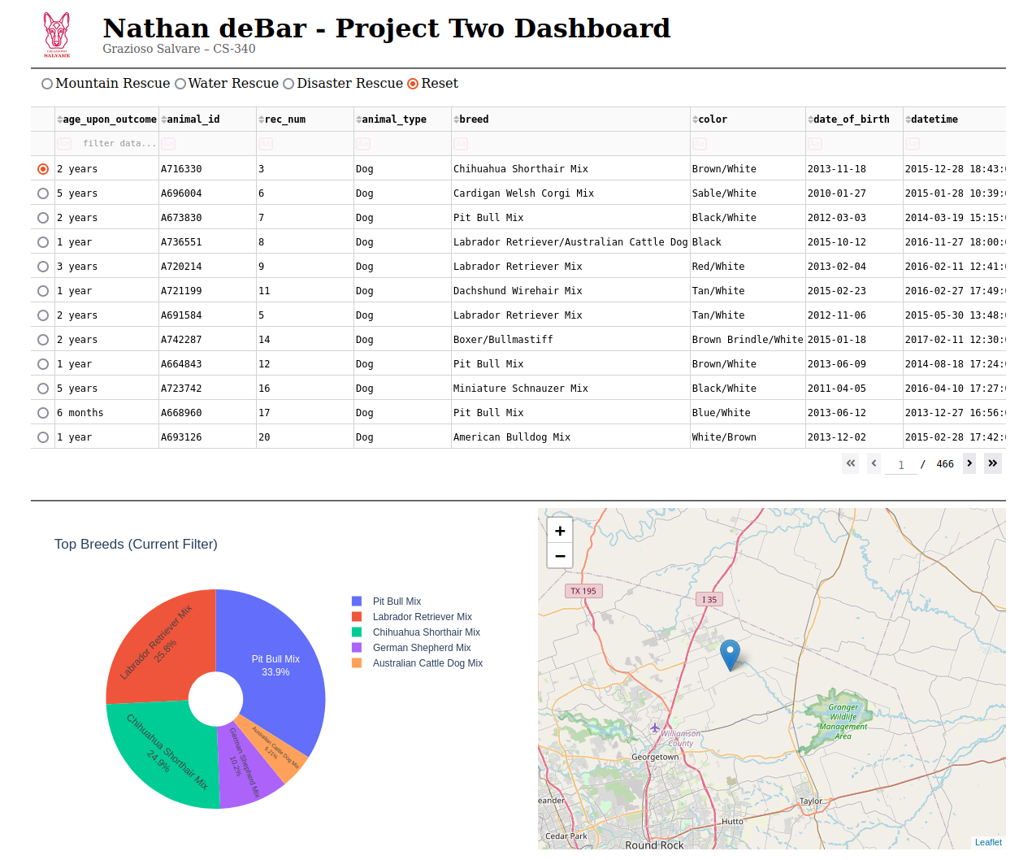

Mountain Rescue selected.
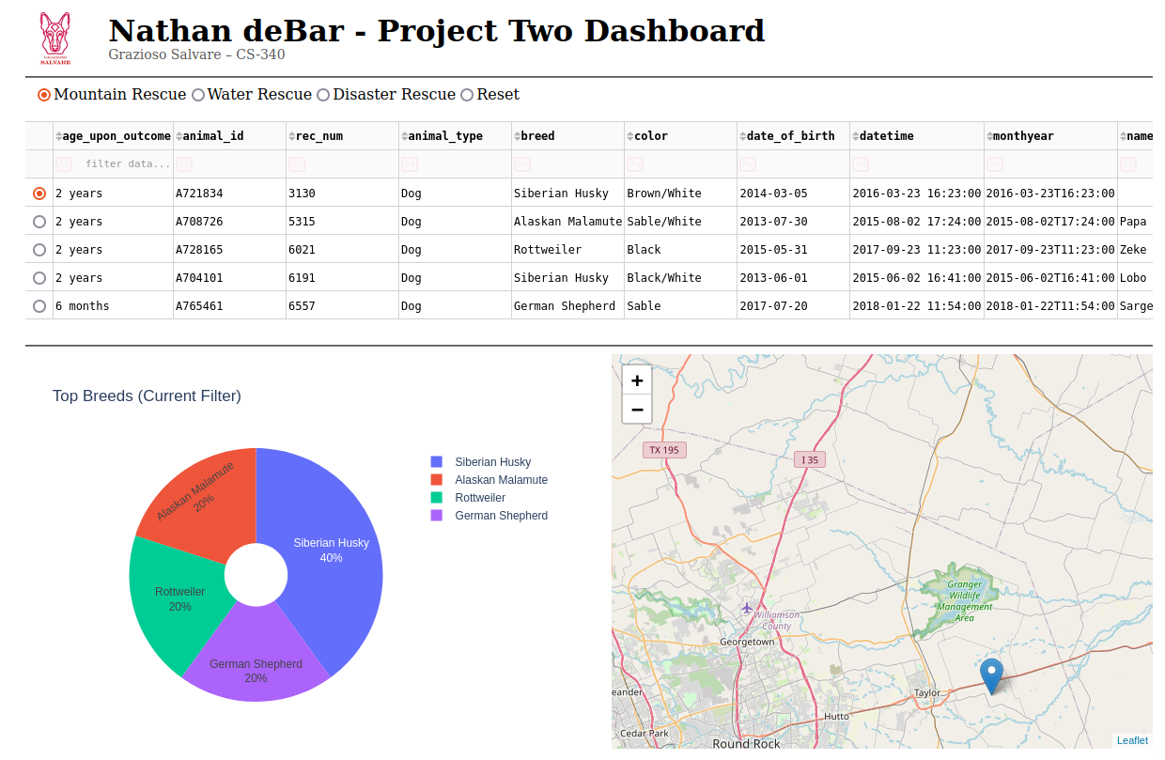
• Water Rescue selected.
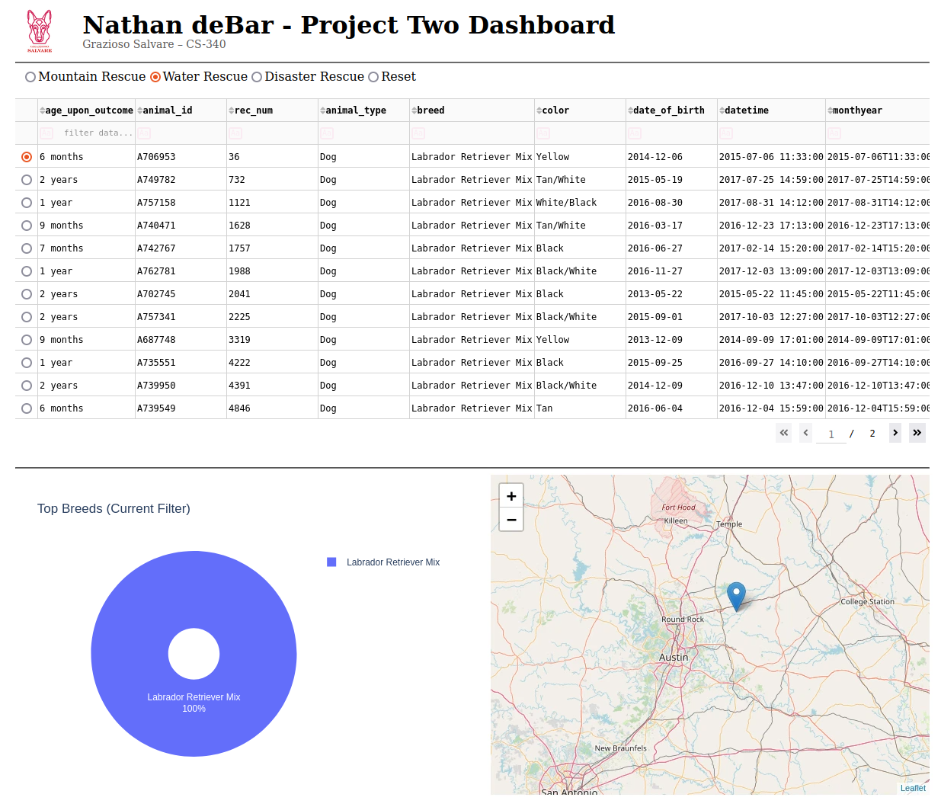
• Disaster Rescue selected.
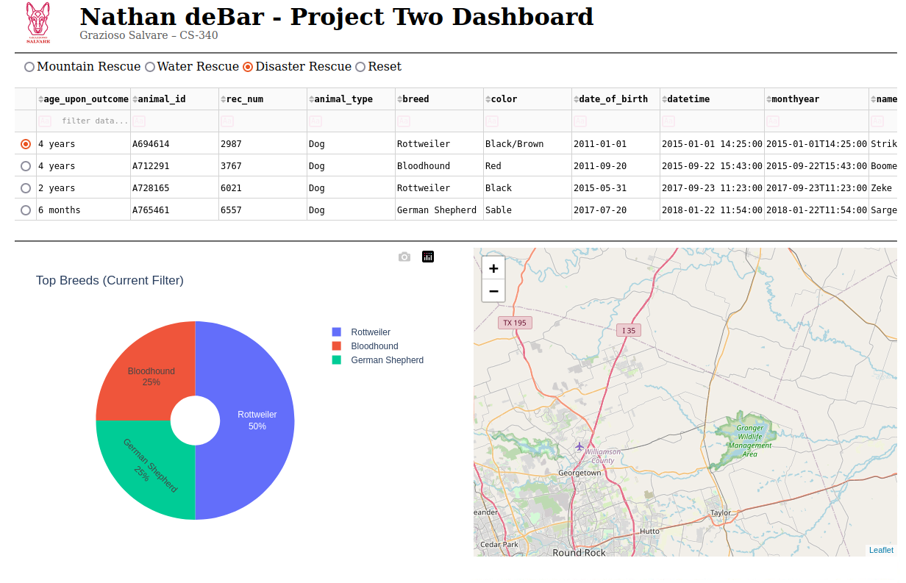
• Reset again.


Troubleshooting
• If the logo does not show, verify the exact filename and that it is in the `assets/` folder.
• If the map shows no marker, the selected row may have missing coordinates; try a different row/filter.
• If the app cannot connect to MongoDB, verify host/port and that aacuser has the correct role.

Challenges & Resolutions
• Breed naming inconsistencies resolved by including both "German Shepherd" and "German Shepherd Dog" in filters.
• Age filtering standardized on age_upon_outcome_in_weeks to avoid parsing text ages.
• Road map implemented via dash_leaflet with OpenStreetMap tiles to avoid external tokens.

Conclusion
This document provides all information needed to install, run, and verify the Grazioso Salvare dashboard. It explains the architecture, filter logic, and operational steps so that stakeholders can reproduce results and maintain the solution.

